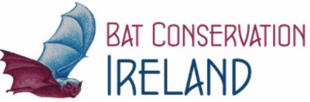

The Bat Conservation Ireland Award

Prize Fund €1,500
Sponsored by Bat Conservation Ireland

Entry Form

Town Name:

Group Name:

Group Contact:

Postal Address:
Telephone:
Email:
Image Description
(300-350 words)

You must also attach (small file-sized) a sketch, drawing or illustration of your proposed sculpture.

Proposed location:
Proposed dimensions:
Proposed Completion of Project (timeline)
Collaboration: | Please list any schools, community groups, organisations and individuals who have collaborated on this submission
Signed on behalf of Group:
Date:
Entries should be emailed to admin@batconservationireland.org

