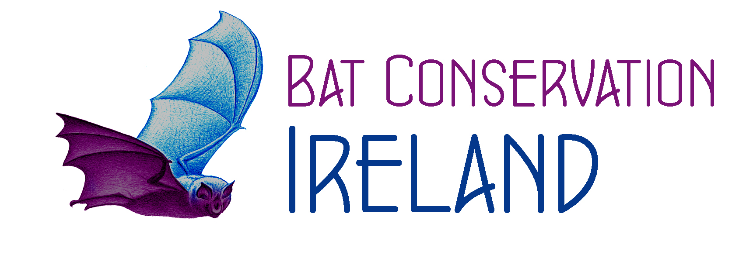 Bat Conservation Ireland Ltd.
General Health & Safety

Bat Conservation Ireland Ltd. consider the safety and the health of all members to be of paramount importance and to this end have taken all reasonable precautions to protect staff and comply with statutory obligations in this regard i.e. Health & Safety at Work Act 2005 and any other relevant legislation.
Equally, it is the duty of all staff (the term staff includes, employees, contracted staff and volunteers) to exercise responsibility and to do everything possible to prevent injury to themselves and to others including service users and colleagues. Detailed health and safety information is available in the Health & Safety Statement which has been issued to all staff. Specifically, the following applies:

- All employees are required to attend and undergo any mandatory training programs that may be determined as essential to enable them to safely carry out their role.

- Employees are required to report any medical conditions that may put an employee’s or their service user’s health and safety at risk in any form.

- All on site fire and first aid instructions should be read, safety regulations observed and potential dangers reported without delay.

- Any accident or incident that occurs at work or must be notified immediately to the Manager on the day it occurs. An incident report sheet must be filled out and submitted to the Manager as well.

- Employee must not use mobile phones whilst driving or carrying out tasks unless calling for help

- All employees must at all times co-operate with Bat Conservation Ireland in respect of all health and safety matters including wearing of personal protective equipment and immediate reporting of defects or any risks that they are aware.

Failure to adhere to health and safety policies and procedures will be dealt with under the disciplinary policy and may be deemed gross misconduct.
At all times, if any staff member has any concern about work activity or their ability to fulfil their duties in a safe manner that will not endanger themselves or others they should raise it directly with the administrator prior to undertaking the activity

