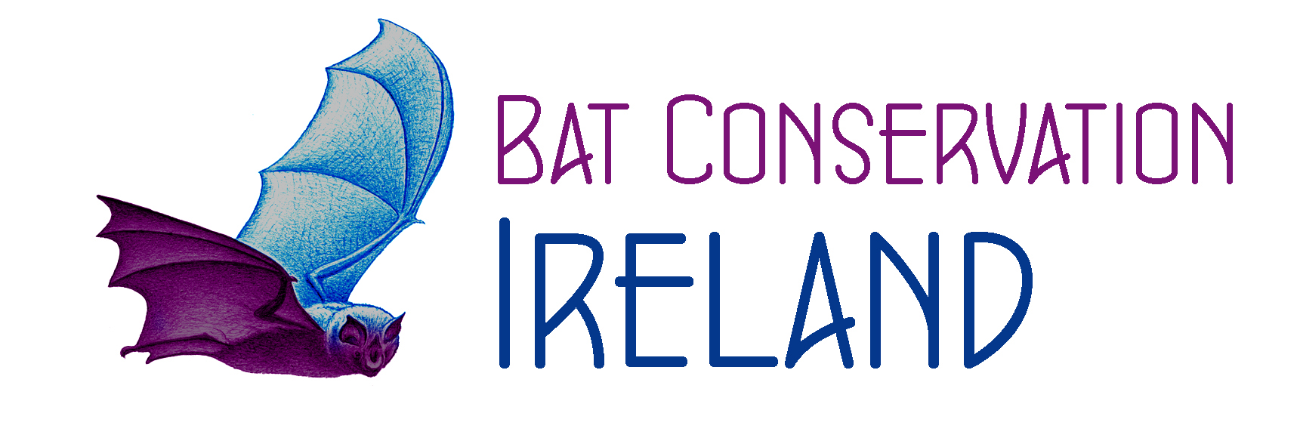 Bat Conservation Ireland
Doctor’s Declaration

All persons involved in bat work which may involve coming into contact with bats (NPWS conservation rangers, consultants, volunteers, scientists etc. - the list is not exhaustive) should be vaccinated against rabies.

A course of three injections should be ordered by prescription in advance and is normally administered by a General Practitioner. Once the vaccine is administered, which should take place as soon as possible after the request is received, please complete the details below as evidence of the applicant having received the vaccinations.

This is to confirm that........................................................................................ (Name) is in receipt

of the ………….. ………………………………………………vaccine (name of rabies vaccine)

Date of 1ST vaccination: ..............................................................
DOCTORS
STAMP
HERE

Date of 2nd vaccination: ............................................................

Date of 3rd vaccination: ...........................................................

OR
Date of first booster vaccination (I year after primary course): .........................................................

OR
Date of subsequent 3-5 year booster vaccination: ..........................................................................................

OR
Date of titre test confirming presence of rabies antibodies: ............................................................................

Signed: ………………………………….......................[GP/ Nurse/Health professional] (delete as appropriate)

Please print name: …………………………………………………………………………………………………..

Date of signature: ……………………………………………………………………….…………………………...

Note: Persons bitten by a bat where the skin is punctured or contact is made with body fluids should additionally receive a course of post exposure vaccinations as soon as possible after exposure.

