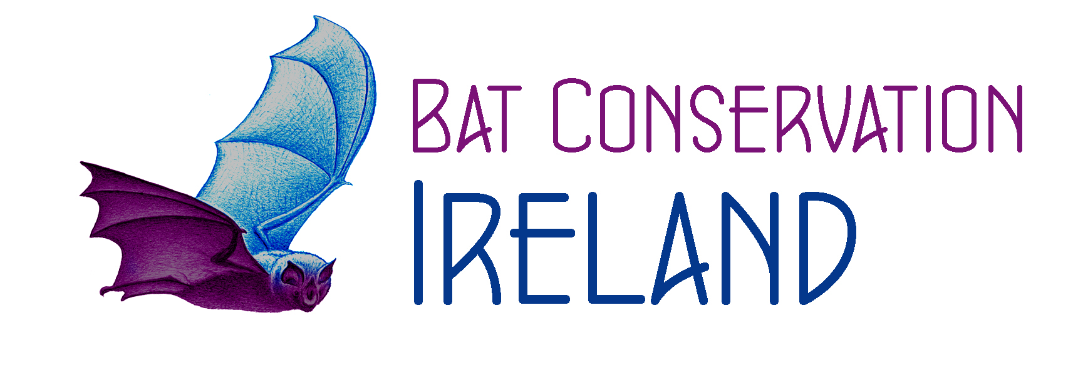
Bat Conservation Ireland Ltd.
Code of Conduct & Ethics Policy for Council Members

The Council of Bat Conservation Ireland Ltd. has adopted this Code of Conduct & Ethics for the Council Members of the Company.
Each Council Member shall be responsible for complying with this Code of Conduct & Ethics.
Each year the code will be reviewed and all Council Members must sign the compliance statement.

Enforcement
The chairperson is ultimately responsible for immediate interpretation, application and enforcement of the Council Members’ Code of Conduct & Ethics Policy. All complaints concerning a possible code violation shall be made in writing to the chairperson with a copy provided to the complainant. The chairperson shall make an initial determination of the issue and shall attempt initial resolution of the problem with the complainer and the complainant.
If this initial attempt at resolution is not successful, the chairperson shall appoint a tribunal composed of three Council Members to investigate the complaint. The tribunal is required to investigate as required and submit a written report to the chair within 30 days. The chair will render his/her decision within ten days of receiving the tribunal’s report.
The Council’s decision may be appealed in writing to the Council for consideration at the Council’s next scheduled meeting for a final decision. The final decision shall be delivered in writing to the complainer and complainant.
Should the chair be the subject of a written complaint, the vice chair shall perform the duties normally assigned to the chair in this matter.
Penalties imposed for breach of the Code of Conduct & Ethics Policy may include, but are not limited to, the following:
- Excluding the Council Member from portions of all future meetings and discussions which relate to the stated conflict of interest, and/or
- Censure of the Council Member , in private, in public, or both, and/or
- Removal of the Council Member from office by a resolution passed by a vote of two-thirds of the members voting at an annual or special general meeting
1. Conflicts of Interest
Every Council Member has a duty to avoid business, financial or other direct or indirect interests or relationships which conflict with the interests of the Company or which divides his or her loyalty to the Company. Each Council Member must disclose to the Chairman, Vice Chairman of any conflict or any appearance of a conflict of interest on his or her part. Any activity which even appears to present such a conflict must be avoided or terminated unless, after such disclosure to the Council, it is determined that the activity is not harmful to the Company or otherwise improper. The end result of the process of disclosure, discussion and consultation may well be approval of certain relationships or transactions on the ground that, despite appearances, they are not harmful to the Company. But all conflicts and appearances of conflicts of interest are prohibited, even if they do not harm the Company, unless they have gone through this process.
Each Council Member must record all interests in the organisations register of directors’ interests and must notify the Council of any relevant changes in their interests when they happen.

2. Conduct of Business and Fair Dealing
No Council Member shall:
- Profit, or assist others to profit, from confidential information or business opportunities that are available because of service to the Company;
- Improperly influence or attempt to influence any business transaction between the Company and another entity in which a Council Member has a direct or indirect financial interest or acts as an employee, officer or Council Member or in a similar capacity; or
- Take unfair advantage of any customer, supplier, competitor or other person through manipulation, concealment, misrepresentation of material facts or other unfair-dealing practice

3. Gifts
No Council Member shall solicit or accept gifts, payments, loans, services or any form of compensation from suppliers, customers, competitors or others seeking to do business with the Company. Social amenities customarily associated with legitimate business relationships are permissible.

4. Compliance with Laws and Regulations
Each Council Member shall comply with all applicable laws, rules and regulations, and shall use all reasonable efforts to oversee compliance by employees, other Council Member with all applicable laws, rules and regulations.
5. Use of Non-Public Information and Disclosure
A Council Member who knows important information about the Company that has not been disclosed to the public must keep such information confidential.
Any Council Member shall maintain the confidentiality of any non-public information learned in the performance of their duties on behalf of the Company, except when disclosure is authorized or legally mandated.
6. Use of Company Funds, Assets and Information
Each Council Member shall protect the Company's funds, assets and information and shall not use the Company funds, assets or information to pursue personal opportunities or gain.
No Company funds, assets or information shall be used for any unlawful purpose.
No undisclosed or unrecorded fund or asset shall be established for any purpose.
No false or artificial entries shall be made in the books and records of the Company for any reason, and no Council Member shall engage in any arrangement that results in such prohibited act.
7. Protecting Organisations Reputation
All Council Members are responsible to act as champions for the organisation by promoting its work and reputation

I HEREBY CERTIFY:
I have read and I commit to comply with Bat Conservation Ireland’s Members of the Council Code of Conduct & Ethics Policy

_________________________ _____________________
Signature of Board Member Date

