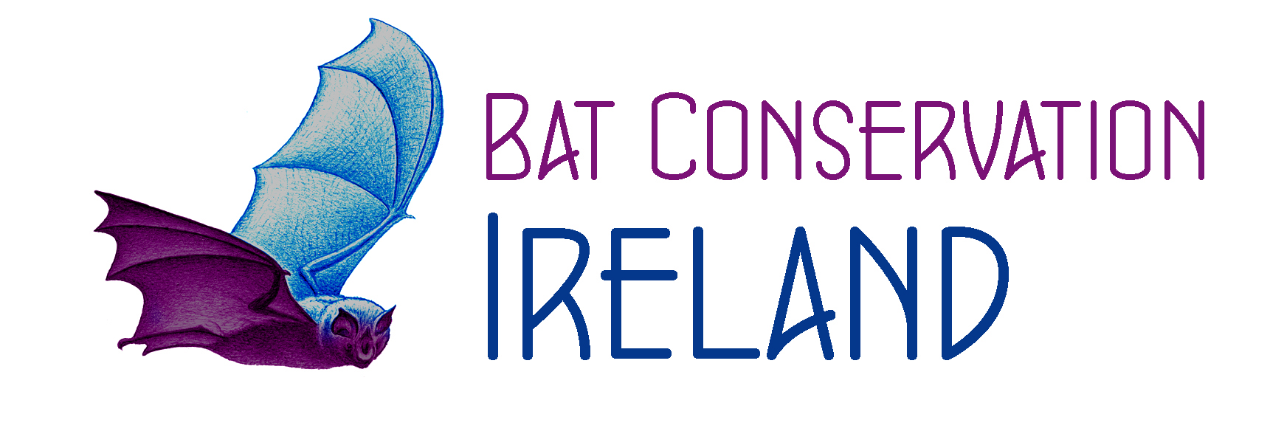 Bat Conservation Ireland Ltd. Child Protection Training Needs

In order to maintain high standards and good practice, all staff (defined as employees, contracted workers and nominated volunteers) should be offered training in child protection.

There are opportunities for all personnel to develop and maintain the necessary attitudes, skills and knowledge to keep children safe.

Everyone who comes into contact with children has a role to play in their protection. To carry out this role confidently and effectively they need to be aware of child protection issues and to have the necessary knowledge and skills to keep children safe.

Criteria for maintaining standards and good practice:

Induction for all staff who work with children, covering Bat Conservation Ireland Ltd. policies and procedures on child protection, when they are nominated to work with Bat Conservation Ireland Ltd.

Training is provided for keeping children safe.
Regular opportunities to update their skills and knowledge should be provided.

Training is provided to those with additional responsibilities such as recruiting and selecting staff, dealing with complaints, disciplinary processes, managing risk or acting as a Designated Liaison Person.

Training programmes are approved by HSE/D and updated in line with current legislation, guidance and best practice.

Induction

An induction programme can help the successful integration of a new staff member.
This programme may include: introductions to Bat Conservation Ireland Ltd. Council Members, colleagues and volunteers, training in Bat Conservation Ireland Ltd. Policies and procedures for subjects such as; the child protection policy, bullying and harassement explanations of day-to-day processes; expectations; conditions and procedures for dealing with discipline; procedures for dealing with grievances and allegations; familiarisation with the ethos of BCI. Familiarity with lines of management and supervision are particularly important.

On appointment, each person will be given:
- The name of the Designated Liaison Person and advised of the DLP’s role in relation to child protection procedures.

- They should also be given a copy of BCI code of good practice for working with children and young people.

Training

All those working in Bat Conservation Ireland Ltd activities, whether as employees, contracted workers or nominated volunteer staff, will be given training in child protection policies and procedures, including information about how to respond to suspicions and allegations of child abuse. To maintain high standards and good practice generally, training will be provided on an ongoing basis.

Ways of providing evidence of meeting training needs:

The following documents can be used to provide evidence that the Training Standard has been met:
Copies of training plans or programmes with dates and times of implementation
Records of course attendance for all attendees
Induction programmes and attendance documentation

