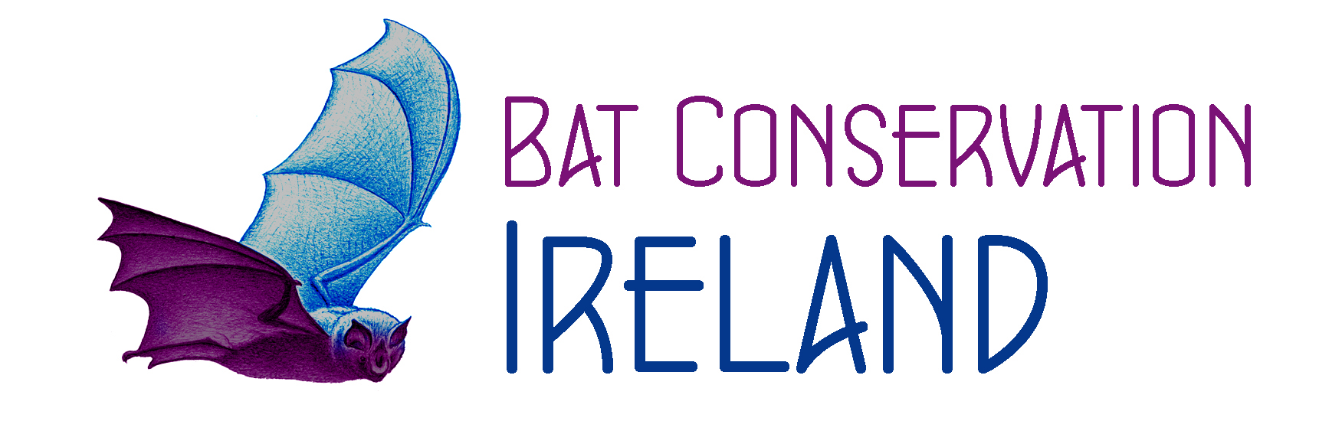 Bat Conservation Ireland Ltd
Guide to organising and leading bat walks

1.0 Health and Safety

1.1 Are you insured?

1.2 It’s very important that you have insurance if you are leading a public bat walk. If you are a Ranger you are probably covered by your employer’s insurance. Bat Groups are covered by Bat Conservation Ireland’s insurance policy for Third Party Cover (Public Liability), including member to member cover to a maximum of €xx Million. This covers general damage to other people or property during the course of voluntary activities such as checking roosts in buildings or bat boxes and taking people on walks and talks. The policy does not cover personal accident or loss of or damage to personal equipment. It is therefore important that you point out any hazards to participants and stress that they must be mindful of their own safety and that of any children they bring with them.

1.3 Public Bat Walks: Health & Safety Policy

The following wording can be used by bat groups to produce a Health and Safety policy document. If you are a Ranger, your employer probably already has a similar policy.
This policy applies to all bat walks organised and run by the X Bat Group. All public bat walks involving the X Bat Group are expected to conform to the following standards.

Planning the Bat Walk
  - The X Bat Group will check any unknown site before agreeing to a proposed bat walk or will check with a reputable person who is familiar with the site, to ensure that the site is suitable as a location for a public bat walk.
  - For all public bat walks the X Bat Group will ensure that it is reasonably confident that bats will be seen at a location where people can stop and watch safely without being crowded.
  - The X Bat Group will ensure that at least two other people in addition to the leader will be available to help run any public bat walks for which it is responsible. These do not have to be X Bat Group members.
  - The X Bat Group will check the access arrangements for a proposed public bat walk location and if any gates will need to be opened for the event. If the site is normally locked at night we shall ensure that someone will be attending who has a key and make arrangements so that participants can leave safely.
  - If the X Bat Group is providing assistance to another organisation or authority that intends to organise and advertise a bat walk it must be agreed in writing when the walk is booked which organisation is responsible for public Health and Safety and for providing third party insurance cover. In general the principle organisers of the event should take this responsibility, but some smaller organisations such as "friends of” groups may not have the necessary insurance.
Publicising the Bat Walk
  - The X Bat Group will try to ensure that any press or other local publicity recommends that people wear suitable clothing and shoes, and that they bring a torch.
  - The X Bat Group will try to make it clear that unaccompanied children will not be permitted on the walk, and that we recommend a maximum of two children per responsible adult for night walks.

Conducting the Bat Walk
  - A Risk Assessment Record will be completed for any proposed public bat walk location at least annually, and a brief recheck made shortly before the actual event.
  - Before setting off on the walk the leader will remind people that it will be getting dark and that those with children should ensure that they know where these children are at all times. Also people should be informed that they are free to leave whenever they wish to, and the exit points pointed out to them.
  - If any significant hazards have been identified, participants should be informed at the start and advised of what precautions they should take.
  - All those people involved in assisting on the walk should be informed of the nearest phone, A&E departments and of any identified hazards, and scheduled to cover these as necessary.

Insurance
The X Bat Group is covered by the BCIreland insurance policy for Third Party Cover (Public Liability), including member to member cover to a maximum of £1 Million. This covers general damage to other people or property during the course of voluntary activities such as checking roosts in buildings or bat boxes and taking people on walks and talks. The policy does not cover personal accident or loss of or damage to personal equipment.

2.0

Generic Risk Assessment for Public Bat Walks

Hazard | Risk  L/M/H | Precautions needed to remove hazard or reduce risk level  One precaution may tackle several hazards
Cuts / abrasions / bruises from slips / trips / falls | H | Make a daytime planning visit to select route for walk to as far as possible avoid narrow paths and/or trip hazards such as tree roots. Advise participants to bring a torch, try to ensure that those that do are distributed among the participants.
Excited children may fail to notice hazards | H | Advise participants that a responsible adult should accompany children. No unaccompanied children under 14 will be permitted to go on the walk.
Bites from insects  Poisonous plants | M | Advise use of insect repellent. This risk is highest at dusk when most bat walks take place. Ensure that walk avoids areas with poisonous plants (such as giant hogweed) or that these are pointed out to participants.
Drowning or hypothermia from falling into rivers or ponds & lakes | H | Ensure that participants are made aware of the position of banks etc. Try to route walk away from any particularly narrow or hazardous areas.
Toxocariasis | L | Risk from contact with dog faeces, particularly to small children. Try to ensure that walk avoids areas of contamination.
Weils disease | L | Only a risk to those who accidentally come into contact with potentially contaminated water. Any such persons should be warned to watch for flu-like symptoms within a few weeks and visit their doctor immediately telling them of the contact with possibly contaminated water.
Problems with dogs | L | Advise any participants bringing a dog that it must be strictly kept on a lead. Consider a policy of discouraging dogs.
Physical assault | L | Advise participants not to become separated from the main body of participants. A group volunteer with a torch should act as back marker while group is on the move.
Accidents & sickness:  General points | L | Ensure that the nearest A&E hospital is known. Make note of the location of the nearest public telephone, or have access to a portable phone.

Risk Level:
L=Low (very unlikely to happen or potential injury is not severe)
M=Medium (may happen or potential injury is moderate and may require treatment)
H=High (could easily happen or potential injury is serious requiring treatment)

2.1

Bat Walk Site Risk Assessment Record

Site Assessed:
Assessed by (print name):
Signature (s):
Assessment Visit date(s):
Hazards noted:

Preventative Measures suggested:

Nearest A&E Hospital:

Nearest Public Telephone (if no mobile signal available)

2.2

Accident Report Form
1. About the person who had the accident.
Give their full name, address and telephone numbers:

2 About you, the person filling in this form
Give your name, address and telephone numbers:

- About the accident
Say:
WHEN it happened:

WHERE it happened.

HOW the accident occurred.
(Give the cause if you can)
If any personal injury, describe what it is, include a simple diagram if necessary:

- Signature of the person filling in the form

