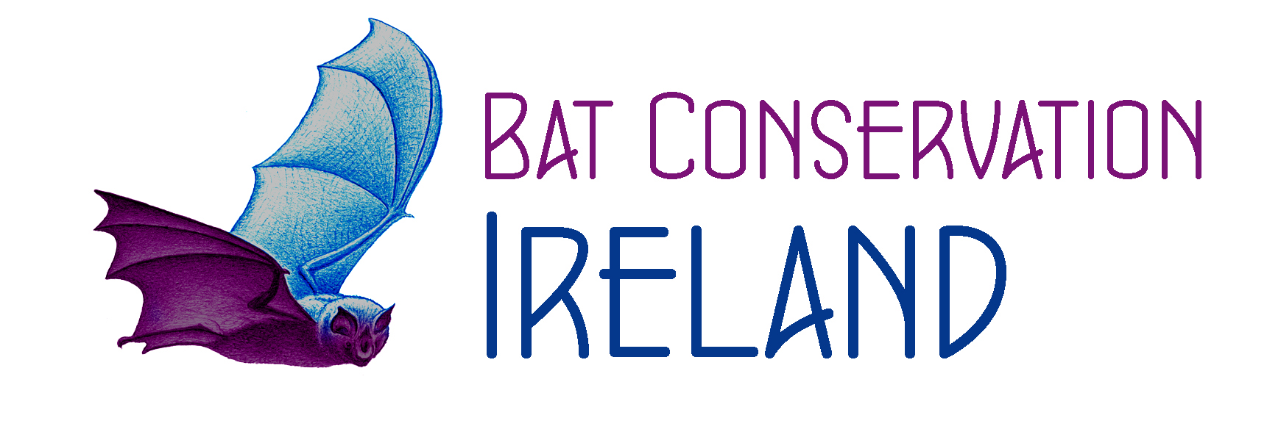 Bat Conservation Ireland Volunteer Policy Statement
Bat Conservation Ireland is committed to providing a professional and efficient service in supporting volunteers.
We recognise that in order to achieve our goals we need to involve volunteers in our own work too. It is also essential that we present a model of good practice in volunteer management. We regard volunteers as a valuable resource and encourage them to get involved at all levels of the organisation and within all appropriate activities. We aim to train, support and supervise our volunteers to the best of our abilities, and to act quickly and fairly if difficulties arise.
1. General Principles
1.1 Purpose of document
The purpose of this Volunteer Policy Statement is to provide guidance on all aspects of volunteering at Bat Conservation Ireland. It does not constitute a binding contract. It supplements other Bat Conservation Ireland policies and procedures, as well as our mission statement and values. These procedures apply to all volunteers who undertake tasks on behalf and at the direction of Bat Conservation Ireland.
1.2. Responsibility
The Bat Conservation Ireland Chair in conjunction with all board members is responsible for ensuring that the policy and the procedures in this document are implemented efficiently and effectively.
1.3. Eligibility
Bat Conservation Ireland will consider involving anyone as a volunteer. Individuals must, however, be able to demonstrate a commitment to the aims of the organisation and may only be placed if their needs as volunteers match the needs of the organisation. No person who has a conflict of interest with any aspect of the organisation will be accepted as a volunteer.
1.4. Appropriate behaviour
Volunteers are expected to work within the policies and procedures of the Bat Conservation Ireland and adhere to its ethos. As representatives of the organisation, they are responsible for presenting a positive image of Bat Conservation Ireland to the outside world.
1.5. Representation of Bat Conservation Ireland
Volunteers must seek prior approval from the Bat Conservation Ireland Manager before undertaking anything that might affect the organisation. This includes, but is not limited to, statements to the press, joint initiatives with other bodies, and agreements involving contractual or financial obligations.
1.6. Confidentiality
Bat Conservation Ireland respects the volunteer’s right to privacy and confidentiality. In turn, volunteers are responsible for maintaining the confidentiality of all privileged information to which they are exposed while volunteering with Bat Conservation Ireland.
1.7. Records
Bat Conservation Ireland has system of records is maintained on all volunteers, including dates and times of service, duties performed, evaluation of work, etc. Volunteer records are accorded the same confidentiality as staff records.
1.8. Service at the discretion of Bat Conservation Ireland
Any voluntary service is at the discretion of Bat Conservation Ireland. Bat Conservation Ireland may, at any time, and for whatever reason, decide to terminate volunteer’s relationships with the organisation. Similarly, volunteers may at any time, and for whatever reason, decide to terminate their relationships with Bat Conservation Ireland. Notice of such decisions should be communicated at the earliest opportunity, preferably in writing.
2. Recruitment
2.1 Role descriptions
Like paid staff, volunteers require a clear and accurate description of the tasks and responsibilities they are expected to undertake. Prior to any volunteer assignment or recruitment effort, a role description must be developed for each voluntary opportunity. The role description may be amended in joint agreement with the volunteer and Bat Conservation Ireland Manager and a copy of the final version must be given to the volunteer before commencing voluntary work
2.2 Applications
Volunteers are recruited on a pro-active basis by the organisation using publicity avenues that are suitable for the roles that need to be filled and potential volunteers may also apply speculatively. Volunteers are recruited in accordance with Bat Conservation Irelands equal opportunities statement. All volunteers are required to complete an application form.
2.3 Interviews
If necessary, applications are short listed and suitable candidates are invited to attend an informal chat with Bat Conservation Ireland Manager, to ascertain their interest in and suitability for the role. Written records of all interviews are kept. All unsuccessful candidates are thanked for applying and encouraged to reapply for other volunteering opportunities, either current or in the future.
2.4 Checks for suitability
References are always taken up. Other checks may also be completed (for example, ascertaining professional qualifications, garda vetting). Volunteers are always warned in advance of the intention to make these checks. If they refuse permission and cannot provide an acceptable reason, they will not be placed.
2.5 Appointment
Formal appointments are made after the role description has been agreed and all necessary checks have proved acceptable.
2.6 Probation
All placements are subject to an initial trial period of one month. At the end of this period, Bat Conservation Ireland Manager meets with the volunteer to discuss the volunteer’s suitability for their role. At this point, volunteers may continue in their current role, be reassigned to a more suitable role, or be asked to leave.
3. Training
3.1 Induction
All volunteers receive induction when they begin voluntary work with Bat Conservation Ireland. This consists of a general introduction to the organisation, as well as a specific orientation on the purposes and requirements of their volunteering role.
3.2 On-the-job training
Volunteers receive initial and ongoing on-the-job training to provide them with the information and skills necessary to perform their tasks well. The training must be appropriate for the demands of the position and the capabilities of the volunteer.
3.3 Additional training
Volunteers are actively encouraged to identify training courses, seminars, conferences, and so on, which would help them to perform their roles better and which would aid their personal development.

4. Supervision
4.1 Lines of communication
Lines of communication should operate in both directions and should exist formally and informally. Volunteers must have access to all appropriate information, memos, materials and meetings relevant to their assignments. Volunteers must be consulted on all decisions that would substantially affect their volunteering conditions.
4.2 Supervisors
Each volunteer must have a clearly identified supervisor who is responsible for the day-to-day management of that volunteer. Bat Conservation Irelands Manager normally takes on the supervisor’s role, but all staff members receive training and guidance on how to involve volunteers effectively in the work of the organisation.
4.3 Supervision sessions
Volunteers receive regular appraisals of their work, based on their role descriptions. Evaluation sessions take place at least once a month between the volunteer and his or her supervisor. These review the performance of the volunteer, suggest any changes in work style, seek suggestions from the volunteer on means of enhancing the volunteer’s relationship with Bat Conservation Ireland, convey appreciation to the volunteer and ascertain the continued interest of the volunteer in serving in his or her role. The sessions also serve as an opportunity to plan future tasks.
4.4 Corrective action
If appropriate, corrective action may be taken following evaluation sessions. Examples include the organisation of training for an identified training need, the reassignment of a volunteer, or the dismissal of a volunteer.
4.5 Dismissal
Volunteers who do not adhere to the organisation’s rules or who fail to perform their volunteer assignments satisfactorily may be subject to dismissal. No volunteers’ involvement will be terminated in writing until the volunteer has had an opportunity to discuss the reasons for possible dismissal with their supervisor. Grounds for dismissal include, but are not limited to, the following: gross misconduct, substance abuse i.e., being under the influence of drugs (including alcohol), theft, misuse of equipment and materials, abuse of clients and co-workers, breaches of confidentiality, failure to abide by Bat Conservation Irelands policies and procedures and failure to complete duties to a satisfactory standard.
4.6 Concerns and grievances
If volunteers are not satisfied that issues relating to their volunteering are being handled appropriately, they are entitled to have their concerns reviewed by the management committee. The management committee will discuss the issue as soon as practical after receiving a written complaint, and take appropriate action. The chair of the management committee makes the ultimate decision.
4.7 Exit interviews
Where possible, informal exit interviews are held with any volunteers who are leaving the organisation, either because they have reached the end of their project, or are leaving for some other reason. Interviews are usually conducted with the volunteer’s ex-supervisor and written records are kept. The session should ascertain why the volunteer is leaving, how they found the volunteering experience and what suggestions they offer to improve the way the organisation operates. The offer of a personal reference for future employment etc. is made to each volunteer.
5. Support and Recognition
5.1 Support
Bat Conservation Ireland endeavours to provide the support necessary to encourage and empower volunteers to make a meaningful contribution and gain significant benefits from their voluntary work. Support forms part of the regular supervision sessions and gives volunteers a safe setting in which to express themselves, let off steam and discuss how they feel about volunteering. The Bat Conservation Ireland manager will always try to be available to volunteers who require support in other areas that are affecting their performance.
5.2 Recognition
Volunteers provide a unique service to Bat Conservation Ireland, the benefits of which are difficult to quantify. It is essential that their efforts are recognised and rewarded. Bat Conservation Ireland staff is responsible for thanking all volunteers informally on a regular basis for the valuable contribution that they make to the organisation. The Bat Conservation Ireland Manager is responsible for ensuring that more formalised recognition takes place at key times.
5.3 Expenses
Volunteers give their time and skills free of charge, so it is essential that the Bat Conservation Ireland offers to reimburse any out-of-pocket expenses they may incur in the course of undertaking voluntary work for the organisation. The costs of volunteering should never be allowed to discourage those on low incomes. Current rates and procedures for claiming expenses are agreed by the management committee and publicised to all volunteers.
5.4 Insurance
Insurance is provided by Bat Conservation Ireland to cover all volunteers working on behalf and at the direction of the organisation.
5.5 Personal and vocational development
Volunteers are encouraged to develop their skills while involved with the organisation and are assisted into assuming additional and greater responsibilities over time, if they desire this.
6. Monitoring and evaluation
6.1 Bat Conservation Ireland volunteer involvement. Bat Conservation Ireland monitors and evaluates volunteer involvement in the organisation on a regular basis and seeks to make ongoing improvements.

