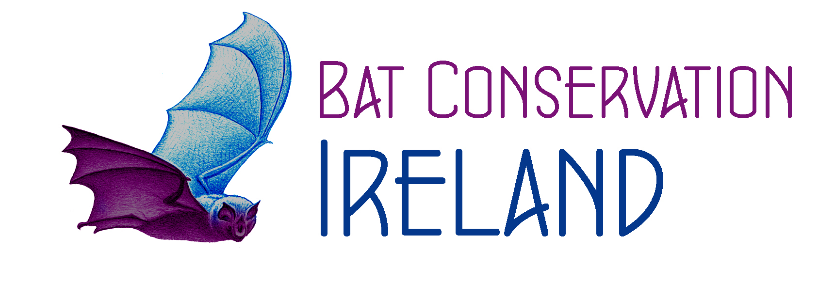 Bat Conservation Ireland Ltd
Data Protection Statement

Purpose of this statement
This policy is a statement of Bat Conservation Ireland Ltd’s commitment to protect the rights and privacy of individuals in accordance with the Data Protection Acts.
Bat Conservation Ireland Ltd is firmly committed to ensuring personal privacy and compliance with the Data Protection Acts, including the provision of best practice guidelines and procedures in relation to all aspects of Data Protection. We shall perform our responsibilities under the Data Protection Acts in accordance with the following eight Data Protection principles:
- Obtain and process information fairly
We shall obtain and process your personal data fairly and in accordance with statutory and other legal obligations.
- Keep it only for one or more specified, explicit and lawful purposes
We shall keep personal data for purposes that are specific, lawful and clearly stated and personal data will only be processed in a manner compatible with these purposes.
- Use and disclose only in ways compatible with these purposes
We shall use and disclose personal data only in circumstances that are necessary for the purposes for which we collected the data.
- Keep it safe and secure
We shall take appropriate security measures against unauthorised access to, or alteration, disclosure or destruction of personal data and against its accidental loss or destruction.
- Keep it accurate, complete and up-to-date
We adopt procedures that ensure high levels of data accuracy, completeness and that data is up-to-date.
- Ensure it is adequate, relevant and not excessive
We shall only hold personal data to the extent that it is adequate, relevant and not excessive.
- Retain for no longer than is necessary
We shall retain personal data for no longer than is necessary
- Give a copy of his/ her personal data to that individual, on request
We adopt procedures to ensure that data subjects can exercise their rights under the Data Protection legislation to access their data.

